Manual Price Reporting Design

Overview

Current processing
Manual Price Reporting functionality allows the price reporter and post superwiser to enter a last sale price for a specific sale.
In the current code base TPFAdapter process gets last sale reports from TPF and publishes these last sale reports on the InternalTicker Channel. MarketDataService picks up this message and recalculates the sale prefix and saves the report in MDH and the republishes the report out on the LastSale channel, CoppBridge and MDB Adapters consume this report and forward it appropriately.

New requirement
- A new screen will be added in the Trader-GUI to be able to enter price reports for a particular product in the specified session.
- Trader GUI will make a Request to MarketDataService running inside the TradeServer on the BC.
- MarketDataService will validate the input,do the price edit checks , save the last sale report in MDH and publish the report out as a LastSale report on the LastSale Event channel.
- This LastSale data will be picked up by the CoppBridge inside TPF Adapter and will be reported to OPRA.
- This LastSale data will also be picked up by the MDB Adapter to be sent to the PDS’s.

Process Flow
The detailed design is explained in two process flows.One is Manual Price Report processing and second flow explains generating end of sales,clear end of sales events and passing these events to Market Data Service for checking while processing for manual price reporting.

Manual Price Reporting flow
- Price Reports will be entered in the newly added screen in Trader GUI.
- Trader GUI will pass the userId and Price Report to MarketDataServiceRoutingProxy(FE)
- Based on configured session Name and classKey, MarketDataServiceRoutingProxy(FE) will pass the details to particular MarketDataService running on BC.
- com.cboe.businessServices.marketDataService.MarketDataService
  - Validate the input. The detailed validations are given in the Validation section of Implentation.
  - Build InternalTickerDetailStruct and RoutingParameterStruct
  - Checks the status of the flag “endOfSalesFlag” and if it is false it will call acceptTickerDetail method of TickerDetailConsumerQueueImpl by passing RoutingParameterStruct and InternalTickerDetailStruct else will throw exception that EndOfSession has already happened.
- com.cboe.businessServices.marketDataService.TickerDetailConsumerQueueImpl
  - Enqueues the details in the Market Data Service Queues.
  - Passes the details to acceptTickerDetail method of MarketDataConsumerQueueImpl class
- com.cboe.businessServices.marketDataService.MarketDataConsumerQueueImp
  - Passes the details to acceptTickerDetails method of MarketDataServiceImpl.
- MarketDataServiceImpl passes the details to MarketDataHistoryService which in turn create the last sale.Market Data Service creates a entry into Market Data History and publishes the the report out as a LastSale report on the Last sale event channel .
Flow Diagram:

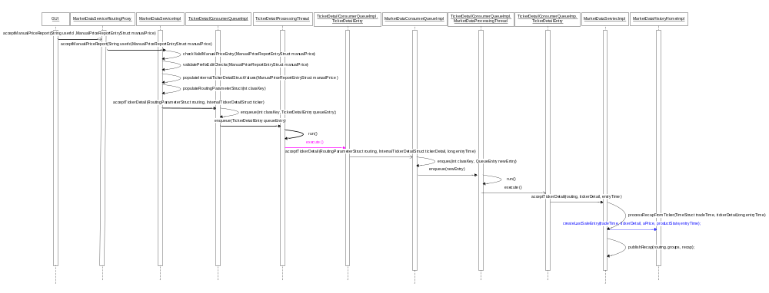
Summary of Validations:
The new requirement performs the following validations

Manual Price Report Data Validations

Following are the validations performed for manual prive report data validations

Sale prefix check i.e. Sale Prefix cannot be null

Throws DataValidationException if null.

Product for price report is not found

Checks if the Buyer Broker Acronym is 5 CHARS in length.
Throws Data Validation Exception if not 5 CHARS

Checks if the Seller Broker Acronym is 5 CHARS in length.
Throws Data Validation Exception if not 5 CHARS

Manual Price Reporting is allowed only for BOB and Hybrid classes.

Price Edit Checks

The list of PriceEdit checks are given in the attached excel sheet.
.
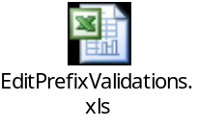

Price Update Checks

Validations already available in existing implementtion are given below

Bypass all updates(NOUPDT)

Subtract input volume from series cumulative volume -Subtract from recap.totalVolume(SIVSCV)

Add input volume to series cummulative volume - add to recap.totalVolume(AIVSCV)

Cancel high price check(CANHIP)

Cancel low price check(CANLOP)

Move zero to all high , low and last sale price fields. This is for CNOL, validation should make sure this is the only trade.( ZRALLC)

Move zero to internal last sale price(ZRILSP)

Move premium price to LSP and time to time of LSP(PRMLSP)

Move zero to previous last sale price and time of previous LSP(ZRPLSP)

Move premium price to opening price(PRMOPN)

Move premium price to previous LSP and time to time of previous LSP(PRMPLS)

Move premium price to high price and time to time of high price(PRMHIP)

Move premium price to low price and time to time of low price(PRMLOP)

High price update routine(HIUPDR)

Low price update routine(LOUPDR)

Validations which are TPF specific and not required are given below

Move prev LSP to last sale price and time of previous lsp to time lsp(PLSLSP)

Move current LSP to internal LSP(PLSILS)

Move second opening price to opening price(SOPROP)

Move zero to second opening price(ZRSCOP)

Move opening price to second opening price(OPNSOP)

Move LSP to previous LSP and time of LSP to previous time of LSP(LSPPLS)

Move premium price to internal LSP(PRMILS)

Move zero to internal last sale suffix(ZRILSS)

Prem price to opening price and set 2nd opening price move condition(PRMOPC)

Move premium price to second opening price(PRMSOP)

Move 'S' to internal last sale suffix(SSILSS)

Move 'Y' to internal last sale suffix (YSILSS)

'W' to internal last sale suffix(WSILSS)

Price Update Validations to be implemented

Subtract 1 from series count of last sale price updates

Add 1 to series count of last sale price

Implementation

IDL Changes

Add struct ManualPriceReportEntryStruct in domain/idl/marketData.idl

typedef string SalePrefix
struct ManualPriceReportEntryStruct
{
cmiProduct::ProductKeysStruct productKeys;
cmiSession::TradingSessionName sessionName ;
cmiUtil::PriceStruct price;
long volume;
cmiUser::ExchangeAcronymStruct buyerBroker;
cmiUser::ExchangeAcronymStruct sellerBroker;
marketData::SalePrefix salePrefix;
cmiUtil::TimeStruct tradeTime;
};

Add the method to interface MarketDataService in server/idl/MarketDataService.idl

void acceptManualPriceReport(in string userId ,in marketData:: ManualPriceReportEntryStruct manualPrice)
raises(
exceptions::SystemException,
exceptions::CommunicationException,
exceptions::DataValidationException,
exceptions::AuthorizationException,
exceptions::NotAcceptedException
);

Add method following methods in TradingSessionMaintenanceService interface of /server/idl/TradingSessionMaintenanceService.idl
void startEndOfSales(in cmiSession::TradingSessionName sessionName, in boolean forceStart, in boolean abortOnError)
raises (
exceptions::SystemException,
exceptions::CommunicationException,
exceptions::AuthorizationException,
exceptions::DataValidationException,
exceptions::TransactionFailedException
);

void startClearEndOfSales (in cmiSession::TradingSessionName sessionName, in boolean forceStart, in boolean abortOnError)
raises (
exceptions::SystemException,
exceptions::CommunicationException,
exceptions::AuthorizationException,
exceptions::DataValidationException,
exceptions::TransactionFailedException
);

Add a new interface SalePrefixes in domain/idl/constants.idl for SalePrefix constants.
interface SalePrefixes
{
const marketData::SalePrefix OPENING_ONLY_TRADE = "OPNL";
const marketData::SalePrefix LATE_REPORTED_TRADE = "LATE";
const marketData::SalePrefix COMPEX_ORDER_TRADE = "SPRD";
const marketData::SalePrefix COMPEX_ORDER_TRADE_STRADDLE = "STDL";
const marketData::SalePrefix OUT_OF_SEQUENCE_TRADE = "OSEQ";
const marketData::SalePrefix CONTRACT_TERM_ADJUSTED_TRADE = "AJST";
const marketData::SalePrefix RE_OPENING_TRADE = "REOP";
const marketData::SalePrefix CANCLE_LAST_TRADE = "CNCL";
const marketData::SalePrefix CANCLE_OPENING_TRADE = "CNCO";
const marketData::SalePrefix CANCLE_ONLY_TRADE = "CNOL";
const marketData::SalePrefix CANCEL_TRADE = "CANC";
const marketData::SalePrefix OPENING_TRADE = "OPEN";
};

Add the following Error Codes to the interface DataValidationCodes in cmiErrorCodes.idl

const exceptions::ErrorCode END_OF_SALE = 1800;
const exceptions::ErrorCode NOT_AN_OPENING_ONLY_TRADE = 1801;
const exceptions::ErrorCode NO_TRADE_SO_FAR = 1802;
const exceptions::ErrorCode NOT_AN_ONLY_TRADE = 1803;
const exceptions::ErrorCode ONLY_OPENING_TRADE_SO_FAR = 1804;
const exceptions::ErrorCode EITHER_LAST_SALE_OR_OPENING_TRADE = 1805;
const exceptions::ErrorCode PRICE_NOT_EQUAL_TO_LAST_SALE = 1806;
const exceptions::ErrorCode CANCELED_VOL_NOT_CUMMULATIVE_VOL = 1807;
const exceptions::ErrorCode PRICE_NOT_EQUAL_TO_OPENING_PRICE = 1808;
const exceptions::ErrorCode PRICE_GREATER_THAN_HIGH = 1809;
const exceptions::ErrorCode PRICE_LESS_THAN_LOW = 1810;
const exceptions::ErrorCode VOLUME_GREATER_THAN_CUMUMATIVE_VOL = 1811;

Add the following method to the interface MarketDataReportService in server/idl/MarketDataReportService.idl
cmiMarketData :: RecapStruct getLatestRecapStruct(in cmiMarketData::TickerStruct
currentCancel)
raises (
exceptions::SystemException,
exceptions::CommunicationException,
exceptions::DataValidationException,
exceptions::AuthorizationException
);

FE changes

com.cboe.proxy.businessServices.MarketDataServiceRoutingProxy

Add method public void acceptManualPriceReport(String userId, ManualPriceReportEntryStruct manualPrice) throws SystemException, CommunicationException, DataValidationException, AuthorizationException, NotAcceptedException
- Based on the session Name and classKey, decide which MarketDataService to call.
- Call acceptManualPriceReport (String userId , ManualPriceReportEntryStruct manualPrice) of MarketDataServiceImpl for that MarketDataService.

MarketDataService Changes

com.cboe.businessServices.marketDataService.MarketDataServiceHomeImpl
    - New member variables

private static final String VALID_SALE_PREFIXES_FOR_MANUAL_PRICE_REPORT_PROPERTY = "validSalePrefixesForManualPriceRpt ";

private static final String EDIT_SALE_PREFIXES_PROPERTY = "editSalePrefix";

private static final String VALIDATIONS_PROPERTY = "validations";

private static final String SESSION = "session";

private static final String MANUAL_PRICE_CHECK="manualPriceCheck";

private static final String BROKER_ACRONYM_LENGTH="brokerAcronymLength";

private static final String SELLER_ACRONYM_LENGTH="sellerAcronymLength";

private static final String OVERRIDE_INDICATOR_LENGTH="overrideIndicator";

private Configuration config;

private HashMap editPrifixValidationsMap;

private String sessionName;

private Integer brokerAcronymLength;

private Integer sellerAcronymLength;

private String overrideIndicator
3.1.1.15 private Boolean manualPriceCheck;

    - New private methods

private Integer[] stringToIntegerArray(String[] input)
This method convert String array to Integer array so that at startup the validation code check is done to verify it is not other than integer.

private void readPriceEditCheckProperties()
This method is called from initialize() , if manualPriceCheck flag from MarketDataService.xml is true ,it calls readSession();
getSessionName();
getSalePrefixValidationMap();
getBrokerAcronymLength();
getSellerAcronymLength();
getOverrideIndicator();

    - New public methods.

public HashMap getSalePrefixValidationMap()
To get HashMap with salePrefix as key and array of Error Codes as value

public boolean getManualPriceCheck()
Get the Manual Price Check from the MarketDataService.xml file.

public int getBrokerAcronymLength()
This method is used to get Broker Acronym length from MarketDataService.xml

public int getSellerAcronymLength()
This method is used to get Seller Acronym length from MarketDataService.xml

public String getOverrideIndicator()
This method is used to get Override indicator from MarketDataService.xml

public String getSessionName()
This method is used to get session name from MarketDataService.xml

Changes in existing methods

public void initialize() method is modified to readPriceEditCheckProperties ();

com.cboe.businessServices.marketDataService.MarketDataServiceImpl
    - New member variables

Define a flag private boolean endOfSalesFlag = false;

private TickerDetailConsumer tickerDetailConsumer

private Recap recap

private MarketDataServiceHomeImpl marketDataServiceHome

private String SPACE=" "

private static final PriceSqlType zero = new PriceSqlType(0.0);
    - New public methods
      - Setter method public void setEndOfSalesFlag(boolean status)
      - Getter method public boolean isEndOfSalesFlag()
      - public void acceptManualPriceReport(String userId, ManualPriceReportEntryStruct manualPrice) throws SystemException, CommunicationException, DataValidationException, AuthorizationException, NotAcceptedException

Checks endOfSalesFlag , if it is true then throws NotAcceptedException.

Validates the input parameters by calling checkValidManualPriceEntry(ManualPriceReportEntryStruct manualPrice)

Validates the input parameters for Price Edit Checks by calling validatePriceEditChecks(ManualPriceReportEntryStruct manualPrice)

Builds InternalTickerDetailStruct by calling populateInternalTickerDetailStruct(ManualPriceReportEntryStruct manualPrice )

Builds RoutingParameterStruct by calling populateRoutingParameterStruct(ManualPriceReportEntryStruct manualPrice)

TickerDetailConsumerQueueImpl.acceptTickerDetail (RoutingParameterStruct routing, InternalTickerDetailStruct tickerDetail).

    - New private methods

private void checkValidManualPriceEntry(ManualPriceReportEntryStruct manualPrice) throws DataValidationException, NotAcceptedException with appropriate message

This method performs the following validations on the incoming data

Sale prefix check i.e. Sale Prefix cannot be null

Throws DataValidationException if null.

Product for price report is not found
    - Call method validateProductKey(String sessionName, int productKey) to perform this check

Checks if the brokerAcronym is 5 CHARS in length.
Throws Data Validation Exception if not 5 CHARS.

Checks if the sellerAcronym is 5 CHARS in length.
Throws Data Validation Exception if not 5 CHARS

To check BrokerAcronym name must be either all alpha or all

Numeric
Throws Data Validation Exception if not all alpha or numeric.

To check SellerAcronym name must be either all alpha or all

Numeric

Throws Data Validation Exception if not all alpha or numeric.

Restrict Manual Price Reporting only for BOB and Hybrid
Check for the session name is W_MAIN .If the session is not W_MAIN throw NotAcceptedException with message as Manual Price Reporting is not supported for the entered products

private void validatePriceEditChecks(ManualPriceReportEntryStruct manualPrice) throws DataValidationException, NotAcceptedException with appropriate message.
This method does all the Edit Prefix validations specified in section Validations for Price Edit Checks

Add Inner Class SalePrefixEditValidator in the method
This class is responsible for all the Edit Prefix validations for the SalePrefixes. The details of each validation, the class will perform, is in section Validations for Price Edit Checks

Following is the list of methods in the class

public boolean verifyPrice(int price) throws DataValidationException

public boolean verifyInputVolume(int volume) throws DataValidationException

public boolean verifyOpeningOnlyTrade() throws NotAcceptedException

public boolean verifyTradesHappened() throws NotAcceptedException

public boolean verifyOnlyTrade() throws NotAcceptedException

public boolean verifyOpeningOnlyTradeSoFar() throws NotAcceptedException

public boolean verifyLastsaleOrOpeningTrade() throws NotAcceptedException

public boolean verifyPriceWithLastSalePrice( int price) throws NotAcceptedException

public boolean verifyInputVolumeWithCumilativeVolume(int volume) throws NotAcceptedException

public boolean verifyPremiumPriceWithOpeningPrice(int price) throws NotAcceptedException

public boolean verifyPremiumPriceLessThanOrEqualToHighPrice(int pric) throws NotAcceptedException

public boolean verifyPremiumPriceGreaterThanOrEqualToLowPrice(int price) throws NotAcceptedException

public boolean verifyInputVolumeLessThanCumilativeVolume(int volume) throws NotAcceptedException

Flow logic:

Create a Hashmap called validationCodesMap.

Puts validation code name as key and integer as value for all the validation codes in validationCodesMap.

Read list of Sale Prefixes from the MarketDataService.xml file

For each SalePrefix list all the validations code names.

Define a for loop on validations code names length.

In the for loop define a switch statement with case equal to value specified for each validation code name in the validationCodesMap.

In the for loop for each validation code name get the value from validationCodesMap and pass the value to the switch statement.

For each case call the corresponding method from SalePrefixEditValidator class.

private InternalTickerDetailStruct populateInternalTickerDetailStruct(ManualPriceReportEntryStruct manualPrice )

This method is required to populate the InternalTickerDetailStruct. This method is called from acceptManualPriceReport(String userId, ManualPriceReportEntryStruct manualPrice)

Extracts ProductKeysStruct from ManualPriceReportEntryStruct

Builds InternalTickerDetailStruct by passing ProductKeysStruct to MarketDataStructBuilder.buildInternalTickerDetailStruct()

Sets the fields of InternalTickerDetailStruct including the passed values and the default values.

Sets the Source as ‘TPF’

Sets the OverrideIndicator to ‘M’

Returns the created InternalTickerDetailStruct object

The mapping of ManualPriceReportEntryStruct with InternalTickerDetailStruct is given in the attached excel sheet.
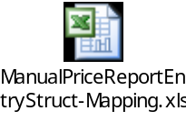

private RoutingParameterStruct populateRoutingParameterStruct(ManualPriceReportEntryStruct manualPrice)

This method populates RoutingParameterStruct.. This method is called from acceptManualPriceReport(String userId, ManualPriceReportEntryStruct manualPrice)

Create an instance of RoutingParameterStruct

Set the groups of newly created instance by calling ConfigurationGroupHelper.getPublishingGroupsForProcessExcludingMine() method

Assing the classkey and session name of the instance from passed ManualPriceReportEntryStruct.

Return the newly RoutingParameterStruct instance.

com.cboe.businessServices.MarketDataService.MarketDataServiceFacade.java
    - New public methods

public void acceptManualPriceReport(String userId, ManualPriceReportEntryStruct manualPrice).
Delegates the call to corresponding MarketDataService.

com.cboe.domain.marketData.RecapImpl

The changes in this class are done to incorporate Price Edit Checks. For this a new variable totalNoOfTrades is added. This variable is incremented with 1 whenever there is an addtion to totalVolume variable in the class and decremented with 1 whenever there is an subtraction from totalVolume.

New Member Variable

private int numberOfTrades;

New Protected methods

Getter method protected int getNumberOfTrades()

New Private Methods

Setter Method private void setNumberOfTrades(int trades)

Changes in existing methods

private void resetLastSaleValues()

Add below setTotalVolume(0) method setNumberOfTrades(0);

public class updateCancelTicker(TickerStruct cancel)

Below setTotalVolume(getTotalVolume() - cancel.lastSaleVolume) method setNumberOfTrades(getNumberOfTrades()-1)

private void updateLastSaleValues(String prefix, PriceSqlType salePrice, int saleVolume)

Below setTotalVolume(saleVolume + getTotalVolume()) method setNumberOfTrades(getNumberOfTrades()+1)

com.cboe.interfaces.domain.marketData.Recap

Add public method getNumberOfTrades()

com.cboe.domain.marketDataSummary.SummaryRecapImpl

Add the blank implementation of getNumberOfTrades() as it implements Recap interface.

- Process flow for endOfSales and clearEndOfSales Events
This section explains the steps required to set the endOfSalesFlag of MarketDataServiceImpl to true or false using ar commands.
- When the user runs the startEndOfSales or StartClearEndOfSales command. The corresponding methods adminStartEndOfSales and adminStartClearEndOfSales of TradingSessionServiceCommands which are registered as admin callback method, are called.
- These methods in turn calls the startEndOfSales and startClearEndOfSales methods respectively of TradingSessionServiceLocalImpl.
- startEndOfSales() and startClearEndOfSales() creates an TradingSessionClientAction object by passing START_END_OF_SALES and START_CLEAR_END_OF_SALES actions. This action is passed to the execute method of TradingSessionServiceLocalImpl.
- The execute method
  - finds the active clients (finds the registered objects on bc server)
  - Creates a callback object for each BObject
  - Publishes the action event is to TradingSession event channel.
  - Sets the event state to TradingSessionEventStates.FIRED
  - Then these events are propogated through the TradingSession event channel to the client who are registered for this event.
Ar command flow for startEndOfSales:
User calls startEndOfSales command by passing parameters session name, forceStart flag, abortOnError flag and list of servers. This scripts sets the endOfSalesFlag of MarketDataServiceImpl to true.
Flow Diagram:
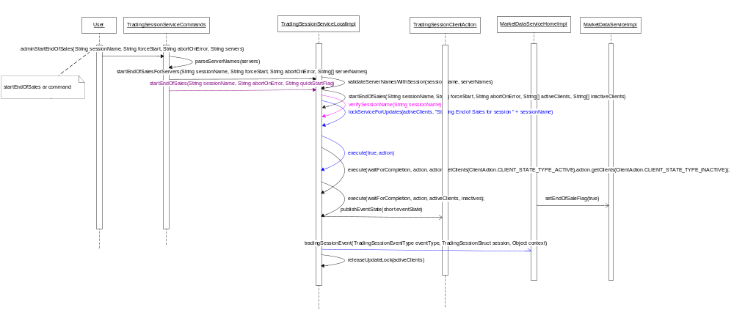

Ar command flow for startClearEndOfSales:
User calls startClearEndOfSales command by passing parameters session name, forceStart flag, abortOnError flag and and list of servers. This scripts sets the endOfSalesFlag of MarketDataServiceImpl to false.
Flow Diagram:
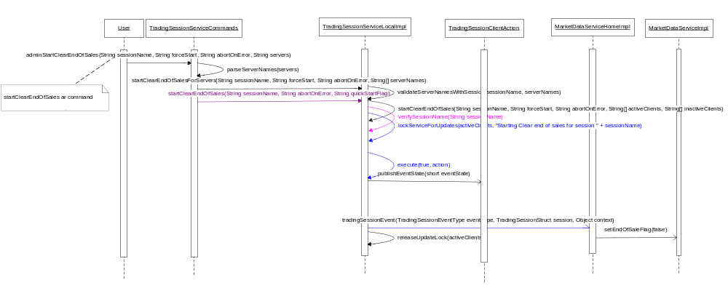

com.cboe.interfaces.businessServices.TradingSessionEventType

New Public Member Variables

Add Event Type member variables for START_END_OF_SALES as public static final TradingSessionEventType START_END_OF_SALES = new TradingSessionEventType(20, " START_END_OF_SALES");

Add Event Type member variables for START_CLEAR_END_OF_SALES as public static final TradingSessionEventType START_CLEAR_END_OF_SALES = new TradingSessionEventType(21, " START_CLEAR_END_OF_SALES");

Modification to Inner Class TradingSessionEventTypeEnumeration

Add newly created member variables (START_END_OF_SALES and START_CLEAR_END_OF_SALES) to “types” field variable.

com.cboe.businessServices.marketDataService.MarketDataServiceHomeImpl

Modify method private void registerForTradingSessionEvents()

Register the events (START_END_OF_SALES and START_CLEAR_END_OF_SALES) with priority as 1.

Modify method public boolean tradingSessionEvent(TradingSessionEventType eventType, TradingSessionStruct session, Object context)

Add check for START_END_OF_SALES, then set “endOfSaleFlags” of MarketDataServiceImpl to true

Add check for START_CLEAR_END_OF_SALES, then set “endOfSalesFlag” of MarketDataServiceImpl to false

com.cboe.businessServices.tradingSessionService.TradingSessionServiceLocalImpl

New methods

private void startEndOfSales(String sessionName, boolean forceStart, boolean abortOnError, String[] activeClients, String[] inactiveClients) throws DataValidationException, TransactionFailedException

Add new inner class StartEndOfSalesThread implementing Runnable interface.
    - Add class member with default access modifiers
      - TradingSession session;
      - String[] activeClients;
      - String[] inactiveClients;
      - boolean forceStart;
      - boolean abortOnError;

    - void run()
      - Create “action” object of TradingSessionClientAction for TradingSessionEventType START_END_OF_SALES.
      - call the execute(true, action) method which internally execute action for end of sale.
      - Check if action.allClientsComplete() is not true then Log the alarm.
      - Release the lock on the servers by calling method releaseUpdateLock(activeClients);

Verify the session name by calling method verifySessionName(String sessionName)

Check if the session is configured for underlying products by calling method TradingSessionNameHelper.isUnderlyingSession(sessionName) else throws DataValidationException

Check If session is applicable by calling method TradingSessionNameHelper.isNotApplicableSession(sessionName) else throws DataValidationException

If BusinessDay is started then
    - lock all the provided active clients for update by calling method lockServiceForUpdates(activeClients, "Starting session " + sessionName);
    - Create a Thread object of StartEndOfSalesThread class by passing session, activeClients and inactiveClients and start the thread.

private void startClearEndOfSales(String sessionName, boolean forceStart, boolean abortOnError, String[] activeClients, String[] inactiveClients) throws DataValidationException, TransactionFailedException

Add new inner class StartClearEndOfSalesThread implementing Runnable interface.
    - Add class member with default access modifiers
      - TradingSession session;
      - String[] activeClients;
      - String[] inactiveClients;
      - boolean forceStart;
      - boolean abortOnError;
    - void run()
      - Create “action” object of TradingSessionClientAction for TradingSessionEventType START_CLEAR_END_OF_SALES.
      - Call the execute(true, action) method which internally execute action for end of sale.
      - Check if action.allClientsComplete() is not true then Log the alarm.
      - Release the lock on the servers by calling method releaseUpdateLock(activeClients);

Verify the session name by calling method verifySessionName(String sessionName)

Check if the session is configured for underlying products by calling method TradingSessionNameHelper.isUnderlyingSession(sessionName) else throws DataValidationException

Check If session is applicable by calling method TradingSessionNameHelper.isNotApplicableSession(sessionName) else throws DataValidationException

If BusinessDay is started then
    - lock all the provided active clients for update by calling method lockServiceForUpdates(activeClients, "Starting session " + sessionName);
    - Create a Thread object of StartClearEndOfSalesThread class by passing session, activeClients and inactiveClients and start the thread.

public void startEndOfSalesForServers(String sessionName, boolean forceStart, boolean abortOnError, String[] serverNames) throws DataValidationException, TransactionFailedException

Validate server names with session by calling method validateServerNamesWithSession(sessionName, serverNames).

Call methods startEndOfSales(sessionName, forceStart, abortOnError, serverNames, new String[0]) for processing.

public void startClearEndOfSalesForServers(String sessionName, boolean forceStart, boolean abortOnError, String[] serverNames) throws DataValidationException, TransactionFailedException

Validate server names with session by calling method validateServerNamesWithSession(sessionName, serverNames).

Then all parametes are passed to methods startClearEndOfSales(sessionName, boolean forceStart, boolean abortOnError, serverNames, new String[0]) for processing.

public void startEndOfSales(String sessionName, boolean forceStart, boolean abortOnError) throws DataValidationException, TransactionFailedException

Call method startEndOfSales(sessionName, registrationMapHome.getActiveClientsForSession(sessionName), registrationMapHome.getInactiveClientsForSession(sessionName), forceStart, abortOnError) for processing.

public void startClearEndOfSales(String sessionName, boolean forceStart, boolean abortOnError) throws DataValidationException, TransactionFailedException

Call method startClearEndOfSales(sessionName, registrationMapHome.getActiveClientsForSession(sessionName), registrationMapHome.getInactiveClientsForSession(sessionName), forceStart, abortOnError) for processing.

com.cboe.businessServices.tradingSessionService.TradingSessionServiceCommands
    - New public methods
      - public void adminStartEndOfSales(String sessionName, String forceStart, String abortOnError, String servers)
        - Call parseServerNames(servers) which creates a string array of servers
        - If servers are found calls the TradingSessionServiceLocalImpl .startEndOfSalesForServers(String sessionName, boolean forceStart, boolean abortOnError, String[] serverNames) method.
        - If no servers are found then TradingSessionServiceLocalImpl.startEndOfSales(String sessionName, boolean forceStart, boolean abortOnError) method will be called

      - public void adminStartClearEndOfSales(String sessionName, String forceStart, String abortOnError, String servers)
        - Call parseServerNames(servers) which creates a string array of servers
        - If servers are found calls the TradingSessionServiceLocalImpl .startClearEndOfSalesForServers(String sessionName, boolean forceStart, boolean abortOnError, String[] serverNames) method.
        - If no servers are found then TradingSessionServiceLocalImpl.startClearEndOfSales(String sessionName, boolean forceStart, boolean abortOnError) method will be called
    - Modification to existing method
      - public void registerCallbacks()
        - Register the methods adminStartEndOfSales() with name “startEndOfSales”
        - Register the methods adminStartClearEndOfSales() with name “startClearEndOfSales”.

com.cboe.interfaces.businessServices.TradingSessionEventGroupType.java
Make entry for START_END_OF_SALES and START_CLEAR_END_OF_SALES

com.cboe.businessServices.tradingSessionService.TradingSessionStrategyFactory.java
    - Modification to existing method
      - public TradingSessionEventGroupType getEventGroup(String sessionName, int event)
        - Check if event is START_END_OF_SALES or START_CLEAR_END_OF_SALES

Scripts()
- Add two scripts startEndOfSales and startClearEndOfSales which will execure ar commands by passing them the Session name, forceStart, abortOnError and Sever name(s).

- Modify appScripts.txt to make entry of endOfsales and clearEndOfSales

Database()
- none

SetContext()
- none

XML/DTD()
- TradingSessionService.dtd
Add the entry of the ar scripts startEndOfSales and startClearEndOfSales in the dtd.
- MarketDataService.dtd
Make entry of validSalePrefixesForManualPriceRpt, editSalePrefix, editSalePrefixProperties.

- MarketDataService.xml

As the MarketDataService will have multiple instances there is no need to have the Manual Price Checks for all instances. So there is a flag <manualPriceCheck booleanValue="true"/> added in each instance section indication if Manual Price checks are required or not

Add the following to the section

<MarketDataServiceHomeImpl name="MarketDataServiceHomeHybridImpl">

To restrict Manual Price Reporting only for BOB and Hybrid Validation

Add a tag session. This tag contains the session Name as W_MAIN
<session>W_MAIN</session>
To get broker Acronym length
<brokerAcronymLength>5</brokerAcronymLength>
To get seller Acronym length.
<sellerAcronymLength>5</sellerAcronymLength>
<manualPriceCheck booleanValue="true"/>
Add the following to the section
<MarketDataServiceHomeImpl name="MarketDataServiceHomeImpl">
<manualPriceCheck booleanValue="true"/>
Add the following to the section
<MarketDataServiceHomeStockImpl name="MarketDataServiceHomeStockImpl">
<manualPriceCheck booleanValue="false"/>
Price Edit Checks:
The Edit Prefixes validations are configurable. For each Prefix the validation is added with a coma separated value in the validations tag of each SalePrefix.

<validSalePrefixesForManualPriceRpt >CANC,CNCL,CNCO,CNOL,LATE,OPNL,OSEQ,
OPEN,REOP,AJST,SPRD,STDL</ validSalePrefixesForManualPriceRpt>
<editSalePrefix name="CANC">
<editSalePrefixProperties>
<validations>1160,1040,1805,1809,1810,1811</validations>
</editSalePrefixProperties>
</editSalePrefix>

<editSalePrefix name="CNCL">
<editSalePrefixProperties>
<validations>1160,1040,1804,1806,1811</validations>
</editSalePrefixProperties>
</editSalePrefix>

<editSalePrefix name="CNCO">
<editSalePrefixProperties>
<validations>1160,1040,1804,1808,1811</validations>
</editSalePrefixProperties>
</editSalePrefix>

<editSalePrefix name="CNOL">
<editSalePrefixProperties>
<validations>1160,1040,1803,1806,1807</validations>
</editSalePrefixProperties>
</editSalePrefix >

<editSalePrefix name="LATE">
<editSalePrefixProperties>
<validations>1160,1040,1802</validations>
</editSalePrefixProperties>
</editSalePrefix >

<editSalePrefix name="OPNL">
<editSalePrefixProperties>
<validations>1160,1040,1801</validations>
</editSalePrefixProperties>
</editSalePrefix >

<editSalePrefix name="OSEQ">
<editSalePrefixProperties>
<validations>1160,1040,1804</validations>
</editSalePrefixProperties>
</editSalePrefix >

<editSalePrefix name="OPEN">
<editSalePrefixProperties>
<validations>1160,1040,1802</validations>
</editSalePrefixProperties>
</editSalePrefix >

<editSalePrefix name="REOP">
<editSalePrefixProperties>
<validations>1160,1040</validations>
</editSalePrefixProperties>
</editSalePrefix >

<editSalePrefix name="AJST">
<editSalePrefixProperties>
<validations>1160,1040</validations>
</editSalePrefixProperties>
</editSalePrefix >

<editSalePrefix name="SPRD">
<editSalePrefixProperties>
<validations>1160,1040</validations>
</editSalePrefixProperties>
</editSalePrefix >

<editSalePrefix name="STDL">
<editSalePrefixProperties>
<validations>1160,1040</validations>
</editSalePrefixProperties>
</editSalePrefix >

Homes/Services()
- See above in the interfaces section.

ImplPlan()
- none

PerformanceTestingProcedure()

OperatorProcedure()
- none

Fallback/Failover

Appendix:
